## Eksplorasi data

### Data ekspor impor

### Data AIS

### *Preprocessing* data AIS

|  |  |  |
| --- | --- | --- |
| Keterangan | Jumlah pesan AIS | Persentase |
| Seluruh pesan AIS | 661,847,517 | 100.0000% |
| Filter 1: MMSI kapal yang valid | 655,794,385 | 99.0854% |
| Filter 2: kapal yang mengalami pelayaran | 640,138,932 | 96.7200% |
| Filter 3: status kapal berlabuh | 154,253,335 | 23.3065% |
| Filter 4: *non-zero draught* | 145,645,162 | 22.0058% |
| Filter 5: tipe kapal yang relevan | 98,837,324 | 14.9335% |

## Indikator yang dikembangkan dari data AIS

### Matriks plot korelasi antara indikator AIS dan statistik ekspor impor

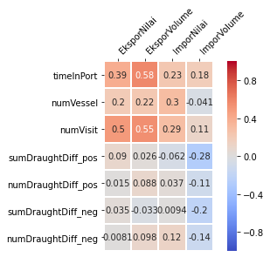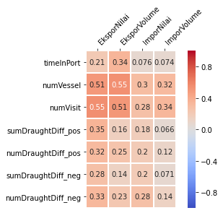

### Perbandingan indikator AIS dan statistik ekspor impor

Diagram garis pertumbuhan

Nilai ekspor

Volume ekspor

Nilai impor

Volume impor

## Kombinasi variabel input

|  |  |  |
| --- | --- | --- |
| Variabel target | Variabel input | |
| Indikator AIS | Indikator AIS terseleksi |
| Nilai ekspor | numVisit, numVessel, timeInPort, sumDraughtDiff_pos, numDraughtDiff_pos | numVessel, sumDraughtDiff_pos |
| Volume ekspor | numVisit, numVessel, timeInPort, sumDraughtDiff_pos, numDraughtDiff_pos | numVessel, sumDraughtDiff_pos, numDraughtDiff_pos |
| Nilai impor | numVisit, numVessel, timeInPort, sumDraughtDiff_neg, numDraughtDiff_neg | numVessel, timeInPort, sumDraughtDiff_neg |
| Volume impor | numVisit, numVessel, timeInPort, sumDraughtDiff_neg, numDraughtDiff_neg | numVessel, timeInPort, sumDraughtDiff_neg |

Nilai ekspor

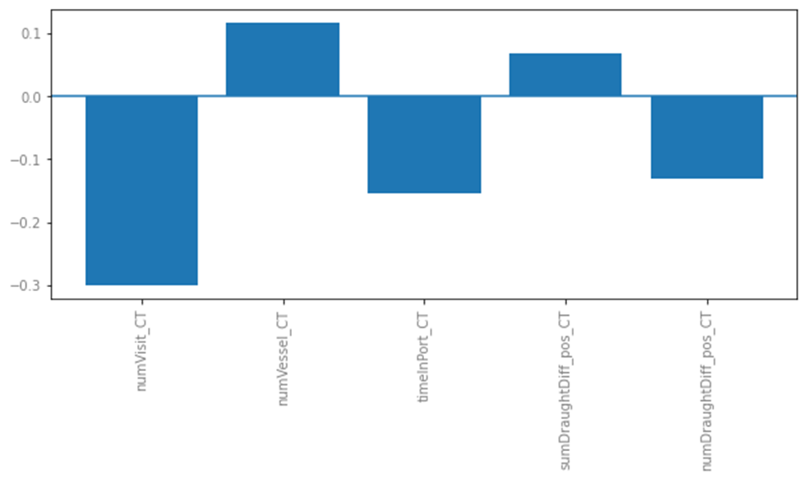

Volume ekspor

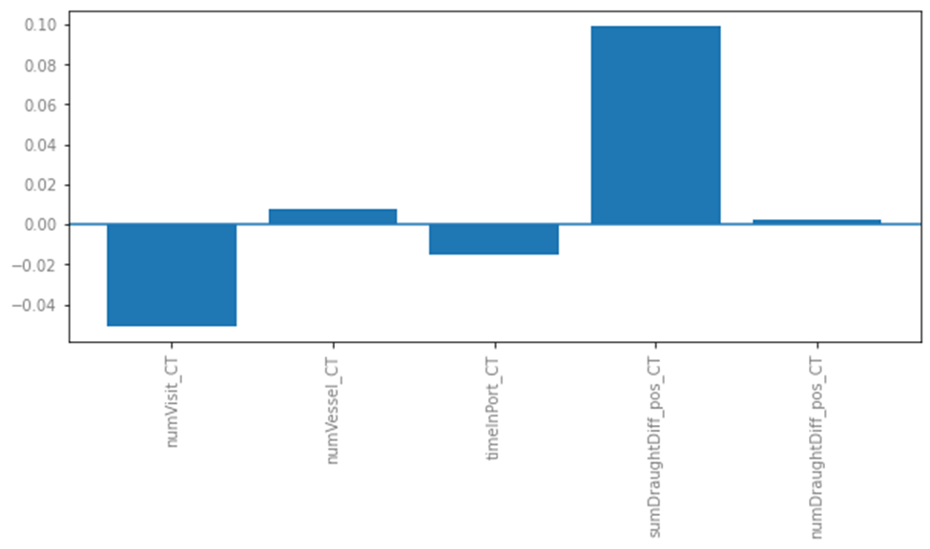

Nilai impor

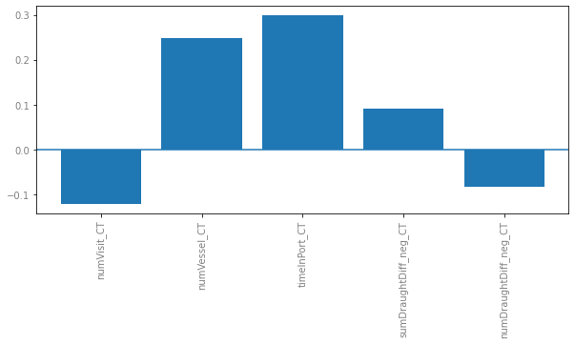

Volume impor

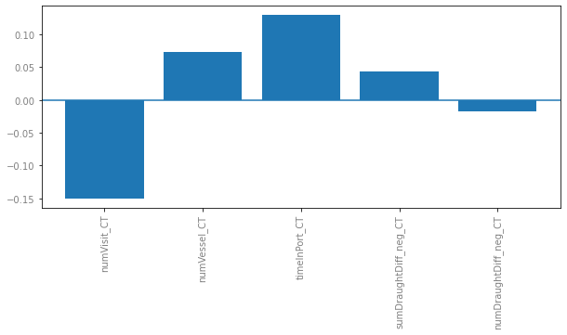

## Pemodelan nowcasting

### Model ANN

Nilai ekspor

|  |  |  |  |
| --- | --- | --- | --- |
| Simulasi Variabel Input | Parameter Model | RMSE | MAPE |
| *All* | hidden_layer': [67, 48], 'activation_function': 'leaky_relu', 'learning_rate': 0.9467, 'momentum': 0.7707 | 1.2118 | 320.66 |
| *Permutation importance* | hidden_layer': [48, 19, 76, 76], 'activation_function': 'relu', 'learning_rate': 0.6268, 'momentum': 0.5187 | 0.931 | 189.03 |
| *Stepwise regression* | hidden_layer': [75, 50, 100], 'activation_function': 'leaky_relu', 'learning_rate': 0.7348, 'momentum': 0.5662 | 0.7852 | 191.45 |
| Signifikansi | hidden_layer': [90, 15], 'activation_function': 'leaky_relu', 'learning_rate': 0.6876, 'momentum': 0.8666 | 1.3935 | 329.97 |
| Korelasi | hidden_layer': [51], 'activation_function': 'leaky_relu', 'learning_rate': 0.7339, 'momentum': 0.8597 | 0.795 | 192.11 |

Volume ekspor

|  |  |  |  |
| --- | --- | --- | --- |
| Simulasi Variabel Input | Parameter Model | RMSE | MAPE |
| *All* | hidden_layer': [57, 69], 'activation_function': 'identity', 'learning_rate': 0.8494, 'momentum': 0.0064 | 1.4106 | 34.525 |
| *Permutation importance* | hidden_layer': [85, 45, 94, 36], 'activation_function': 'tanh', 'learning_rate': 0.8264, 'momentum': 0.0100 | 1.3347 | 31.298 |
| *Stepwise regression* | hidden_layer': [54, 34], 'activation_function': 'leaky_relu', 'learning_rate': 0.1079, 'momentum': 0.0250 | 1.2974 | 32.403 |
| Signifikansi | hidden_layer': [52, 24], 'activation_function': 'tanh', 'learning_rate': 0.2102, 'momentum': 0.4446 | 1.2938 | 31.404 |
| Korelasi | hidden_layer': [60, 9, 69], 'activation_function': 'leaky_relu', 'learning_rate': 0.1513, 'momentum': 0.4370 | 1.2305 | 30.739 |

Nilai impor

|  |  |  |  |
| --- | --- | --- | --- |
| Simulasi Variabel Input | Parameter Model | RMSE | MAPE |
| *All* | hidden_layer': [44, 37, 97], 'activation_function': 'leaky_relu', 'learning_rate': 0.9957, 'momentum': 0.4588 | 1.0299 | 194.91 |
| *Permutation importance* | hidden_layer': [86, 45, 80, 33], 'activation_function': 'relu', 'learning_rate': 0.6399, 'momentum': 0.9879 | 1.2387 | 254.8 |
| *Stepwise regression* | hidden_layer': [94, 75], 'activation_function': 'relu', 'learning_rate': 0.2646, 'momentum': 0.7573 | 1.4943 | 301.19 |
| Signifikansi | hidden_layer': [93, 98, 39], 'activation_function': 'leaky_relu', 'learning_rate': 0.7759, 'momentum': 0.8019 | 1.2611 | 266.1 |
| Korelasi | hidden_layer': [39, 92, 95], 'activation_function': 'leaky_relu', 'learning_rate': 0.8068, 'momentum': 0.9174 | 1.5844 | 239.2 |

Volume impor

AIS reg: numVessel, timeInPort, sumDraughtDiff_neg

|  |  |  |  |
| --- | --- | --- | --- |
| Simulasi Variabel Input | Parameter Model | RMSE | MAPE |
| *All* | hidden_layer': [66, 90, 87], 'activation_function': 'leaky_relu', 'learning_rate': 0.8208, 'momentum': 0.7799 | 1.4515 | 500.09 |
| *Permutation importance* | hidden_layer': [62, 88, 91], 'activation_function': 'leaky_relu', 'learning_rate': 0.9829, 'momentum': 0.5484 | 0.7581 | 105.63 |
| *Stepwise regression* | hidden_layer': [68, 83], 'activation_function': 'relu', 'learning_rate': 0.5709, 'momentum': 0.6296 | 1.2394 | 172.73 |
| Signifikansi | hidden_layer': [29, 62, 89], 'activation_function': 'relu', 'learning_rate': 0.6797, 'momentum': 0.8485 | 1.1988 | 380.39 |
| Korelasi | hidden_layer': [65, 35, 85], 'activation_function': 'leaky_relu', 'learning_rate': 0.7216, 'momentum': 0.8013 | 1.4102 | 416.56 |

### Model ARIMA

Nilai ekspor

|  |  |  |  |
| --- | --- | --- | --- |
| Simulasi Variabel Input | Parameter Model | RMSE | MAPE |
| *All* | ARIMA (2, 0, 0) | 1.6388 | 222.88 |
| *Permutation importance* | ARIMA (11, 0, 0) | 1.4856 | 207.38 |
| *Stepwise regression* | ARIMA (10, 0, 0) | 1.2496 | 234.09 |
| Signifikansi | ARIMA (0, 0, 2) | 1.4063 | 261.32 |
| Korelasi | ARIMA (8, 0, 0) | 1.8891 | 450.06 |

Volume ekspor

|  |  |  |  |
| --- | --- | --- | --- |
| Simulasi Variabel Input | Parameter Model | RMSE | MAPE |
| *All* | ARIMA (2, 0, 2) | 1.8301 | 42.567 |
| *Permutation importance* | ARIMA (1, 0, 0) | 1.9395 | 48.547 |
| *Stepwise regression* | ARIMA (0, 0, 1) | 1.2391 | 31.25 |
| Signifikansi | ARIMA (1, 0, 0) | 1.7833 | 43.487 |
| Korelasi | ARIMA (2, 0, 2) | 1.8389 | 41.98 |

Nilai impor

|  |  |  |  |
| --- | --- | --- | --- |
| Simulasi Variabel Input | Parameter Model | RMSE | MAPE |
| *All* | ARIMA (2, 0, 2) | 1.0004 | 126.17 |
| *Permutation importance* | ARIMA (2, 0, 0) | 0.9077 | 153.7 |
| *Stepwise regression* | ARIMA (2, 0, 0) | 0.9944 | 186.42 |
| Signifikansi | ARIMA (7, 0, 0) | 2.2097 | 474.03 |
| Korelasi | ARIMA (2, 0, 0) | 0.9061 | 142.69 |

Volume impor

|  |  |  |  |
| --- | --- | --- | --- |
| Simulasi Variabel Input | Parameter Model | RMSE | MAPE |
| *All* | ARIMA (0, 0, 0) | 1.7721 | 471.22 |
| *Permutation importance* | ARIMA (10, 0, 2) | 1.6655 | 463.61 |
| *Stepwise regression* | ARIMA (1, 0, 0) | 1.4441 | 369.72 |
| Signifikansi | ARIMA (1, 0, 0) | 1.4441 | 369.72 |
| Korelasi | ARIMA (1, 0, 0) | 1.6684 | 378.42 |

## Perbandingan model ANN dan ARIMA

|  |  |  |  |  |
| --- | --- | --- | --- | --- |
| Variabel target | ANN | | ARIMA | |
| RMSE | MAPE | RMSE | MAPE |
| Nilai ekspor | 0.7852 | 191.45 | 1.2496 | 234.09 |
| Volume ekspor | 1.2305 | 30.739 | 1.2391 | 31.25 |
| Nilai impor | 1.0299 | 194.91 | 0.9061 | 142.69 |
| Volume impor | 0.7581 | 105.63 | 1.4441 | 369.72 |

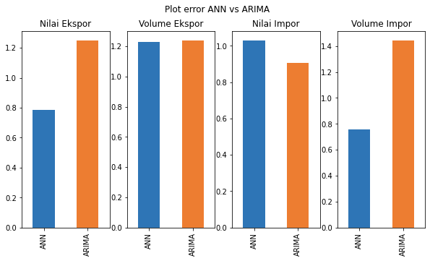

|  |  |  |
| --- | --- | --- |
| Variabel target | Variabel input | Parameter model |
| Nilai ekspor | numVessel, sumDraughtDiff_pos, kurs USD | hidden_layer: [18, 12, 84], activation_function: relu, learning_rate: 0.9335, momentum: 0.9793 |
| Volume ekspor | numVessel, sumDraughtDiff_pos, numDraughtDiff_pos, kurs USD | hidden_layer: [71, 84, 79, 8], activation_function: leaky_relu, learning_rate: 0.8840, momentum: 0.4806 |
| Nilai impor | numVessel, timeInPort, sumDraughtDiff_neg, kurs USD | ARIMA(10,0,0) |
| Volume impor | numVessel, timeInPort, sumDraughtDiff_neg | hidden_layer: [43, 50], activation_function: relu, learning_rate: 0.9683, momentum: 0.9704 |

## Hasil peramalan dengan model terbaik

1. Nilai ekspor (Juta USD)

|  |  |  |
| --- | --- | --- |
| Bulan | Hasil Peramalan | Nilai Aktual |
| Agustus 2020 | 13,284.45 | 13,095.78 |
| September 2020 | 13,809.87 | 13,960.53 |
| Oktober 2020 | 14,795.31 | 14,362.24 |
| November 2020 | 14,899.13 | 15,259.32 |
| Desember 2020 | 16,391.71 | 16,538.31 |

1. Volume ekspor (Ribu ton)

|  |  |  |
| --- | --- | --- |
| Bulan | Hasil Peramalan | Nilai Aktual |
| Agustus 2020 | 47,033.03 | 43,579.67 |
| September 2020 | 47,403.91 | 43,944.14 |
| Oktober 2020 | 49,928.65 | 47,217.68 |
| November 2020 | 52,222.63 | 53,282.46 |
| Desember 2020 | 54,796.92 | 57,324.02 |

1. Nilai impor (Juta USD)

|  |  |  |
| --- | --- | --- |
| Bulan | Hasil Peramalan | Nilai Aktual |
| Agustus 2020 | 10,569.24 | 10,742.41 |
| September 2020 | 10,101.10 | 11,570.10 |
| Oktober 2020 | 11,222.02 | 10,786.02 |
| November 2020 | 11,863.75 | 12,664.41 |
| Desember 2020 | 13,224.28 | 14,438.38 |

1. Volume impor (Ribu ton)

|  |  |  |
| --- | --- | --- |
| Bulan | Hasil Peramalan | Nilai Aktual |
| Agustus 2020 | 11,115.19 | 11,839.69 |
| September 2020 | 11,227.53 | 12,883.23 |
| Oktober 2020 | 11,524.09 | 12,091.55 |
| November 2020 | 12,303.78 | 12,137.15 |
| Desember 2020 | 14,320.50 | 15,330.67 |

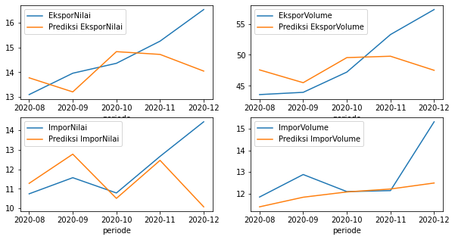

Setelah filter

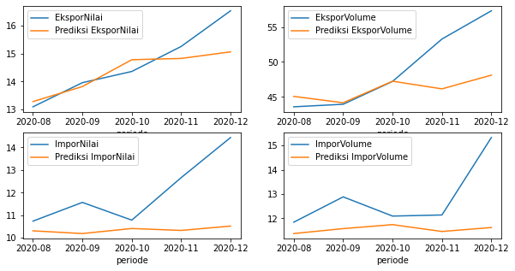

Sebelum filter

Nilai ekspor 1

ARIMAX Results

==============================================================================

Dep. Variable: EksporNilai No. Observations: 19

Model: ARIMA(2, 0, 0) Log Likelihood -8.842

Date: Tue, 06 Jul 2021 AIC 35.683

Time: 16:06:18 BIC 44.183

Sample: 01-01-2019 HQIC 37.122

- 07-01-2020

Covariance Type: opg

=========================================================================================

coef std err z P>|z| [0.025 0.975]

-----------------------------------------------------------------------------------------

const 0.0227 0.057 0.397 0.691 -0.089 0.135

numVisit 1.0526 0.194 5.423 0.000 0.672 1.433

numVessel -0.4018 0.181 -2.219 0.027 -0.757 -0.047

timeInPort -0.5147 0.148 -3.486 0.000 -0.804 -0.225

sumDraughtDiff_pos 0.3193 0.219 1.461 0.144 -0.109 0.748

numDraughtDiff_pos 0.1630 0.216 0.754 0.451 -0.260 0.587

ar.L1 -1.3059 0.284 -4.597 0.000 -1.863 -0.749

ar.L2 -0.6560 0.255 -2.574 0.010 -1.155 -0.157

sigma2 0.1330 0.103 1.287 0.198 -0.070 0.335

===================================================================================

Ljung-Box (L1) (Q): 0.85 Jarque-Bera (JB): 0.70

Prob(Q): 0.36 Prob(JB): 0.71

Heteroskedasticity (H): 1.02 Skew: 0.24

Prob(H) (two-sided): 0.98 Kurtosis: 2.19

===================================================================================

Warnings:

[1] Covariance matrix calculated using the outer product of gradients (complex-step).

2

ARIMAX Results

==============================================================================

Dep. Variable: EksporNilai No. Observations: 19

Model: ARIMA(11, 0, 0) Log Likelihood -8.187

Date: Tue, 06 Jul 2021 AIC 46.374

Time: 16:12:48 BIC 60.540

Sample: 01-01-2019 HQIC 48.771

- 07-01-2020

Covariance Type: opg

=========================================================================================

coef std err z P>|z| [0.025 0.975]

-----------------------------------------------------------------------------------------

const -0.0105 0.047 -0.223 0.823 -0.103 0.082

numVessel 0.2884 0.124 2.330 0.020 0.046 0.531

sumDraughtDiff_pos 0.2971 0.094 3.151 0.002 0.112 0.482

ar.L1 -0.5741 1.590 -0.361 0.718 -3.691 2.543

ar.L2 -0.3369 1.745 -0.193 0.847 -3.757 3.083

ar.L3 -0.1526 2.063 -0.074 0.941 -4.197 3.892

ar.L4 0.3915 1.694 0.231 0.817 -2.928 3.711

ar.L5 0.7128 0.464 1.536 0.125 -0.197 1.623

ar.L6 -0.5139 1.210 -0.425 0.671 -2.886 1.859

ar.L7 -0.7479 0.257 -2.914 0.004 -1.251 -0.245

ar.L8 -0.5553 1.150 -0.483 0.629 -2.809 1.699

ar.L9 -0.4927 2.093 -0.235 0.814 -4.595 3.610

ar.L10 -0.2694 2.207 -0.122 0.903 -4.596 4.057

ar.L11 0.5783 1.743 0.332 0.740 -2.837 3.994

sigma2 0.0293 0.100 0.294 0.769 -0.166 0.225

===================================================================================

Ljung-Box (L1) (Q): 0.32 Jarque-Bera (JB): 1.29

Prob(Q): 0.57 Prob(JB): 0.53

Heteroskedasticity (H): 2.55 Skew: -0.47

Prob(H) (two-sided): 0.28 Kurtosis: 2.14

===================================================================================

Warnings:

[1] Covariance matrix calculated using the outer product of gradients (complex-step).

3

ARIMAX Results

==============================================================================

Dep. Variable: EksporNilai No. Observations: 19

Model: ARIMA(10, 0, 0) Log Likelihood -5.204

Date: Tue, 06 Jul 2021 AIC 36.409

Time: 16:13:25 BIC 48.687

Sample: 01-01-2019 HQIC 38.487

- 07-01-2020

Covariance Type: opg

===============================================================================

coef std err z P>|z| [0.025 0.975]

-------------------------------------------------------------------------------

const -0.0356 0.014 -2.579 0.010 -0.063 -0.009

numVisit 0.8890 0.425 2.090 0.037 0.056 1.723

ar.L1 -1.7668 0.816 -2.166 0.030 -3.366 -0.168

ar.L2 -0.9898 0.909 -1.088 0.276 -2.772 0.793

ar.L3 -0.3578 1.215 -0.294 0.768 -2.739 2.024

ar.L4 -1.0762 0.293 -3.672 0.000 -1.651 -0.502

ar.L5 -1.5693 0.465 -3.372 0.001 -2.481 -0.657

ar.L6 -0.7798 0.876 -0.890 0.373 -2.497 0.937

ar.L7 -0.3665 1.003 -0.365 0.715 -2.332 1.599

ar.L8 -1.3821 0.695 -1.989 0.047 -2.744 -0.020

ar.L9 -1.6355 0.861 -1.900 0.057 -3.323 0.052

ar.L10 -0.6560 0.384 -1.708 0.088 -1.409 0.097

sigma2 0.0197 0.062 0.319 0.750 -0.101 0.141

===================================================================================

Ljung-Box (L1) (Q): 0.39 Jarque-Bera (JB): 1.94

Prob(Q): 0.53 Prob(JB): 0.38

Heteroskedasticity (H): 5.58 Skew: -0.73

Prob(H) (two-sided): 0.06 Kurtosis: 3.58

===================================================================================

Warnings:

[1] Covariance matrix calculated using the outer product of gradients (complex-step).

4

ARIMAX Results

==============================================================================

Dep. Variable: EksporNilai No. Observations: 19

Model: ARIMA(0, 0, 2) Log Likelihood -10.094

Date: Tue, 06 Jul 2021 AIC 34.189

Time: 16:14:18 BIC 40.800

Sample: 01-01-2019 HQIC 35.308

- 07-01-2020

Covariance Type: opg

=================================================================================

coef std err z P>|z| [0.025 0.975]

---------------------------------------------------------------------------------

const -0.0272 0.007 -3.707 0.000 -0.042 -0.013

numVisit 1.1691 0.186 6.281 0.000 0.804 1.534

numVessel -0.4110 0.136 -3.012 0.003 -0.678 -0.144

timeInPort -0.5088 0.129 -3.943 0.000 -0.762 -0.256

ma.L1 -1.9523 11.044 -0.177 0.860 -23.598 19.694

ma.L2 0.9900 11.139 0.089 0.929 -20.842 22.821

sigma2 0.1122 1.251 0.090 0.929 -2.341 2.565

===================================================================================

Ljung-Box (L1) (Q): 0.01 Jarque-Bera (JB): 0.89

Prob(Q): 0.91 Prob(JB): 0.64

Heteroskedasticity (H): 0.53 Skew: 0.52

Prob(H) (two-sided): 0.46 Kurtosis: 3.25

===================================================================================

Warnings:

[1] Covariance matrix calculated using the outer product of gradients (complex-step).

5

ARIMAX Results

==============================================================================

Dep. Variable: EksporNilai No. Observations: 19

Model: ARIMA(8, 0, 0) Log Likelihood -6.933

Date: Tue, 06 Jul 2021 AIC 41.867

Time: 16:14:45 BIC 55.089

Sample: 01-01-2019 HQIC 44.105

- 07-01-2020

Covariance Type: opg

=========================================================================================

coef std err z P>|z| [0.025 0.975]

-----------------------------------------------------------------------------------------

const -0.0346 0.110 -0.313 0.754 -0.251 0.182

numVisit 0.7186 0.268 2.676 0.007 0.192 1.245

numVessel 0.1336 0.330 0.405 0.685 -0.512 0.780

sumDraughtDiff_pos 1.0099 0.484 2.087 0.037 0.061 1.958

numDraughtDiff_pos -0.9484 0.446 -2.128 0.033 -1.822 -0.075

ar.L1 -0.8479 0.232 -3.655 0.000 -1.303 -0.393

ar.L2 0.3921 0.529 0.741 0.459 -0.645 1.430

ar.L3 0.2246 0.423 0.531 0.596 -0.605 1.054

ar.L4 -0.3276 0.695 -0.471 0.637 -1.690 1.035

ar.L5 0.0799 1.033 0.077 0.938 -1.944 2.104

ar.L6 0.2413 0.548 0.441 0.660 -0.832 1.315

ar.L7 -0.8007 0.813 -0.985 0.325 -2.395 0.793

ar.L8 -0.8152 0.316 -2.579 0.010 -1.435 -0.196

sigma2 0.0623 0.093 0.667 0.505 -0.121 0.245

===================================================================================

Ljung-Box (L1) (Q): 0.12 Jarque-Bera (JB): 0.41

Prob(Q): 0.73 Prob(JB): 0.81

Heteroskedasticity (H): 1.57 Skew: -0.35

Prob(H) (two-sided): 0.60 Kurtosis: 3.21

===================================================================================

Warnings:

[1] Covariance matrix calculated using the outer product of gradients (complex-step).

Volume ekspor

1

ARIMAX Results

==============================================================================

Dep. Variable: EksporVolume No. Observations: 19

Model: ARIMA(2, 0, 2) Log Likelihood -21.686

Date: Tue, 06 Jul 2021 AIC 65.372

Time: 16:16:27 BIC 75.760

Sample: 01-01-2019 HQIC 67.130

- 07-01-2020

Covariance Type: opg

=========================================================================================

coef std err z P>|z| [0.025 0.975]

-----------------------------------------------------------------------------------------

const -3.4568 2.848 -1.214 0.225 -9.039 2.126

numVisit 0.8647 0.375 2.306 0.021 0.130 1.600

numVessel -0.2149 0.282 -0.763 0.446 -0.767 0.337

timeInPort -0.1462 0.258 -0.566 0.572 -0.653 0.360

sumDraughtDiff_pos -0.5230 0.402 -1.301 0.193 -1.311 0.265

numDraughtDiff_pos 0.6130 0.504 1.217 0.223 -0.374 1.600

ar.L1 -0.9286 0.241 -3.847 0.000 -1.402 -0.455

ar.L2 -0.7490 0.261 -2.869 0.004 -1.261 -0.237

ma.L1 0.0304 0.482 0.063 0.950 -0.914 0.974

ma.L2 0.9822 8.778 0.112 0.911 -16.222 18.186

sigma2 0.4149 3.608 0.115 0.908 -6.656 7.486

===================================================================================

Ljung-Box (L1) (Q): 0.15 Jarque-Bera (JB): 0.72

Prob(Q): 0.69 Prob(JB): 0.70

Heteroskedasticity (H): 0.45 Skew: 0.06

Prob(H) (two-sided): 0.36 Kurtosis: 2.05

===================================================================================

Warnings:

[1] Covariance matrix calculated using the outer product of gradients (complex-step).

2

ARIMAX Results

==============================================================================

Dep. Variable: EksporVolume No. Observations: 19

Model: ARIMA(1, 0, 0) Log Likelihood -26.437

Date: Tue, 06 Jul 2021 AIC 66.873

Time: 16:17:06 BIC 73.485

Sample: 01-01-2019 HQIC 67.992

- 07-01-2020

Covariance Type: opg

=========================================================================================

coef std err z P>|z| [0.025 0.975]

-----------------------------------------------------------------------------------------

const -3.6499 2.659 -1.373 0.170 -8.862 1.562

numVisit 0.7113 0.324 2.196 0.028 0.076 1.346

numVessel -0.1475 0.333 -0.443 0.658 -0.801 0.506

sumDraughtDiff_pos 0.0106 0.587 0.018 0.986 -1.141 1.162

numDraughtDiff_pos -0.1140 0.560 -0.204 0.839 -1.211 0.983

ar.L1 -0.6695 0.288 -2.326 0.020 -1.234 -0.105

sigma2 0.9169 0.420 2.182 0.029 0.093 1.740

===================================================================================

Ljung-Box (L1) (Q): 0.98 Jarque-Bera (JB): 0.44

Prob(Q): 0.32 Prob(JB): 0.80

Heteroskedasticity (H): 2.76 Skew: 0.11

Prob(H) (two-sided): 0.24 Kurtosis: 2.28

===================================================================================

Warnings:

[1] Covariance matrix calculated using the outer product of gradients (complex-step).

3

ARIMAX Results

==============================================================================

Dep. Variable: EksporVolume No. Observations: 19

Model: ARIMA(0, 0, 1) Log Likelihood -30.000

Date: Tue, 06 Jul 2021 AIC 68.001

Time: 16:17:30 BIC 71.779

Sample: 01-01-2019 HQIC 68.640

- 07-01-2020

Covariance Type: opg

================================================================================

coef std err z P>|z| [0.025 0.975]

--------------------------------------------------------------------------------

const -0.9445 1.782 -0.530 0.596 -4.437 2.548

numVessel 0.4035 0.186 2.164 0.030 0.038 0.769

ma.L1 -0.5878 0.218 -2.700 0.007 -1.014 -0.161

sigma2 1.3462 0.856 1.572 0.116 -0.332 3.024

===================================================================================

Ljung-Box (L1) (Q): 0.03 Jarque-Bera (JB): 1.57

Prob(Q): 0.87 Prob(JB): 0.46

Heteroskedasticity (H): 0.56 Skew: 0.15

Prob(H) (two-sided): 0.49 Kurtosis: 1.62

===================================================================================

Warnings:

[1] Covariance matrix calculated using the outer product of gradients (complex-step).

4

ARIMAX Results

==============================================================================

Dep. Variable: EksporVolume No. Observations: 19

Model: ARIMA(1, 0, 0) Log Likelihood -26.738

Date: Tue, 06 Jul 2021 AIC 61.476

Time: 16:17:57 BIC 65.254

Sample: 01-01-2019 HQIC 62.115

- 07-01-2020

Covariance Type: opg

===============================================================================

coef std err z P>|z| [0.025 0.975]

-------------------------------------------------------------------------------

const -2.4567 0.754 -3.257 0.001 -3.935 -0.978

numVisit 0.5770 0.202 2.853 0.004 0.181 0.973

ar.L1 -0.6171 0.236 -2.611 0.009 -1.080 -0.154

sigma2 0.9526 0.444 2.146 0.032 0.082 1.823

===================================================================================

Ljung-Box (L1) (Q): 0.96 Jarque-Bera (JB): 0.53

Prob(Q): 0.33 Prob(JB): 0.77

Heteroskedasticity (H): 2.01 Skew: 0.13

Prob(H) (two-sided): 0.42 Kurtosis: 2.22

===================================================================================

Warnings:

[1] Covariance matrix calculated using the outer product of gradients (complex-step).

5

ARIMAX Results

==============================================================================

Dep. Variable: EksporVolume No. Observations: 19

Model: ARIMA(2, 0, 2) Log Likelihood -22.708

Date: Tue, 06 Jul 2021 AIC 65.417

Time: 16:18:26 BIC 74.861

Sample: 01-01-2019 HQIC 67.015

- 07-01-2020

Covariance Type: opg

=========================================================================================

coef std err z P>|z| [0.025 0.975]

-----------------------------------------------------------------------------------------

const -3.5620 2.993 -1.190 0.234 -9.428 2.304

numVisit 0.8086 0.268 3.012 0.003 0.282 1.335

numVessel -0.2372 0.274 -0.866 0.387 -0.774 0.300

timeInPort -0.0096 0.223 -0.043 0.966 -0.447 0.428

numDraughtDiff_pos 0.0885 0.290 0.305 0.761 -0.481 0.658

ar.L1 -1.0994 0.309 -3.556 0.000 -1.705 -0.493

ar.L2 -0.8470 0.406 -2.089 0.037 -1.642 -0.052

ma.L1 0.4441 2.485 0.179 0.858 -4.426 5.314

ma.L2 0.9818 9.649 0.102 0.919 -17.930 19.894

sigma2 0.4701 4.260 0.110 0.912 -7.880 8.820

===================================================================================

Ljung-Box (L1) (Q): 0.35 Jarque-Bera (JB): 0.35

Prob(Q): 0.56 Prob(JB): 0.84

Heteroskedasticity (H): 0.53 Skew: 0.26

Prob(H) (two-sided): 0.46 Kurtosis: 2.59

===================================================================================

Warnings:

[1] Covariance matrix calculated using the outer product of gradients (complex-step).

Nilai impor

1

ARIMAX Results

==============================================================================

Dep. Variable: ImporNilai No. Observations: 19

Model: ARIMA(2, 0, 2) Log Likelihood -8.296

Date: Tue, 06 Jul 2021 AIC 38.591

Time: 16:19:01 BIC 48.980

Sample: 01-01-2019 HQIC 40.350

- 07-01-2020

Covariance Type: opg

=========================================================================================

coef std err z P>|z| [0.025 0.975]

-----------------------------------------------------------------------------------------

const 0.0430 0.018 2.348 0.019 0.007 0.079

numVisit 0.9593 0.269 3.567 0.000 0.432 1.486

numVessel -0.2861 0.267 -1.070 0.285 -0.810 0.238

timeInPort -0.4460 0.199 -2.238 0.025 -0.837 -0.055

sumDraughtDiff_neg -0.7970 0.610 -1.306 0.192 -1.993 0.399

numDraughtDiff_neg 0.8807 0.617 1.427 0.154 -0.329 2.090

ar.L1 -1.2360 0.389 -3.178 0.001 -1.998 -0.474

ar.L2 -0.8302 0.221 -3.757 0.000 -1.263 -0.397

ma.L1 0.0573 7.597 0.008 0.994 -14.832 14.947

ma.L2 -0.9148 4.972 -0.184 0.854 -10.660 8.830

sigma2 0.0947 0.473 0.200 0.841 -0.833 1.023

===================================================================================

Ljung-Box (L1) (Q): 0.01 Jarque-Bera (JB): 1.35

Prob(Q): 0.92 Prob(JB): 0.51

Heteroskedasticity (H): 0.88 Skew: -0.33

Prob(H) (two-sided): 0.88 Kurtosis: 1.87

===================================================================================

Warnings:

[1] Covariance matrix calculated using the outer product of gradients (complex-step).

2

ARIMAX Results

==============================================================================

Dep. Variable: ImporNilai No. Observations: 19

Model: ARIMA(2, 0, 0) Log Likelihood -20.466

Date: Tue, 06 Jul 2021 AIC 54.932

Time: 16:19:28 BIC 61.543

Sample: 01-01-2019 HQIC 56.051

- 07-01-2020

Covariance Type: opg

=========================================================================================

coef std err z P>|z| [0.025 0.975]

-----------------------------------------------------------------------------------------

const 0.0168 0.112 0.150 0.881 -0.203 0.237

numVessel 0.2240 0.271 0.825 0.409 -0.308 0.756

timeInPort -0.1186 0.322 -0.369 0.712 -0.749 0.512

sumDraughtDiff_neg 0.1106 0.377 0.293 0.769 -0.628 0.849

ar.L1 -0.6724 0.331 -2.030 0.042 -1.322 -0.023

ar.L2 -0.5877 0.230 -2.552 0.011 -1.039 -0.136

sigma2 0.4778 0.208 2.298 0.022 0.070 0.885

===================================================================================

Ljung-Box (L1) (Q): 0.00 Jarque-Bera (JB): 0.33

Prob(Q): 0.95 Prob(JB): 0.85

Heteroskedasticity (H): 1.14 Skew: -0.12

Prob(H) (two-sided): 0.88 Kurtosis: 2.40

===================================================================================

Warnings:

[1] Covariance matrix calculated using the outer product of gradients (complex-step).

3

ARIMAX Results

==============================================================================

Dep. Variable: ImporNilai No. Observations: 19

Model: ARIMA(2, 0, 0) Log Likelihood -20.677

Date: Tue, 06 Jul 2021 AIC 51.354

Time: 16:19:51 BIC 56.077

Sample: 01-01-2019 HQIC 52.153

- 07-01-2020

Covariance Type: opg

================================================================================

coef std err z P>|z| [0.025 0.975]

--------------------------------------------------------------------------------

const 0.0100 0.105 0.095 0.924 -0.195 0.215

numVessel 0.2015 0.197 1.021 0.307 -0.185 0.588

ar.L1 -0.6725 0.271 -2.484 0.013 -1.203 -0.142

ar.L2 -0.6093 0.188 -3.234 0.001 -0.979 -0.240

sigma2 0.4866 0.197 2.472 0.013 0.101 0.872

===================================================================================

Ljung-Box (L1) (Q): 0.00 Jarque-Bera (JB): 0.24

Prob(Q): 0.98 Prob(JB): 0.89

Heteroskedasticity (H): 1.31 Skew: -0.06

Prob(H) (two-sided): 0.75 Kurtosis: 2.46

===================================================================================

Warnings:

[1] Covariance matrix calculated using the outer product of gradients (complex-step).

4

ARIMAX Results

==============================================================================

Dep. Variable: ImporNilai No. Observations: 19

Model: ARIMA(7, 0, 0) Log Likelihood -11.629

Date: Tue, 06 Jul 2021 AIC 45.259

Time: 16:20:16 BIC 55.647

Sample: 01-01-2019 HQIC 47.017

- 07-01-2020

Covariance Type: opg

=================================================================================

coef std err z P>|z| [0.025 0.975]

---------------------------------------------------------------------------------

const 0.0306 0.009 3.349 0.001 0.013 0.048

numVisit 0.7610 0.052 14.679 0.000 0.659 0.863

timeInPort -0.8213 0.079 -10.425 0.000 -0.976 -0.667

ar.L1 -2.1492 0.975 -2.205 0.027 -4.059 -0.239

ar.L2 -2.8638 2.137 -1.340 0.180 -7.051 1.324

ar.L3 -3.0591 2.730 -1.121 0.262 -8.410 2.292

ar.L4 -3.0408 2.730 -1.114 0.265 -8.391 2.309

ar.L5 -2.4691 2.482 -0.995 0.320 -7.335 2.396

ar.L6 -1.4045 1.913 -0.734 0.463 -5.153 2.344

ar.L7 -0.3628 0.843 -0.430 0.667 -2.015 1.289

sigma2 0.1173 0.187 0.627 0.531 -0.249 0.484

===================================================================================

Ljung-Box (L1) (Q): 0.06 Jarque-Bera (JB): 0.79

Prob(Q): 0.81 Prob(JB): 0.67

Heteroskedasticity (H): 1.06 Skew: -0.25

Prob(H) (two-sided): 0.94 Kurtosis: 2.13

===================================================================================

Warnings:

[1] Covariance matrix calculated using the outer product of gradients (complex-step).

5

ARIMAX Results

==============================================================================

Dep. Variable: ImporNilai No. Observations: 19

Model: ARIMA(2, 0, 0) Log Likelihood -16.414

Date: Tue, 06 Jul 2021 AIC 46.827

Time: 16:20:36 BIC 53.438

Sample: 01-01-2019 HQIC 47.946

- 07-01-2020

Covariance Type: opg

=========================================================================================

coef std err z P>|z| [0.025 0.975]

-----------------------------------------------------------------------------------------

const 0.0052 0.080 0.065 0.948 -0.152 0.162

numVisit 0.7381 0.358 2.064 0.039 0.037 1.439

numVessel -0.3013 0.421 -0.716 0.474 -1.126 0.523

numDraughtDiff_neg -0.0791 0.269 -0.294 0.769 -0.607 0.449

ar.L1 -0.9033 0.182 -4.961 0.000 -1.260 -0.546

ar.L2 -0.7417 0.184 -4.033 0.000 -1.102 -0.381

sigma2 0.2980 0.129 2.304 0.021 0.045 0.551

===================================================================================

Ljung-Box (L1) (Q): 0.07 Jarque-Bera (JB): 0.16

Prob(Q): 0.79 Prob(JB): 0.92

Heteroskedasticity (H): 4.14 Skew: -0.14

Prob(H) (two-sided): 0.11 Kurtosis: 2.65

===================================================================================

Warnings:

[1] Covariance matrix calculated using the outer product of gradients (complex-step).

Volume impor

1

ARIMAX Results

==============================================================================

Dep. Variable: ImporVolume No. Observations: 19

Model: ARIMA Log Likelihood -18.959

Date: Tue, 06 Jul 2021 AIC 51.919

Time: 16:21:06 BIC 58.530

Sample: 01-01-2019 HQIC 53.038

- 07-01-2020

Covariance Type: opg

=========================================================================================

coef std err z P>|z| [0.025 0.975]

-----------------------------------------------------------------------------------------

const -4.925e-06 0.219 -2.25e-05 1.000 -0.429 0.429

numVisit 1.1049 0.463 2.385 0.017 0.197 2.013

numVessel -0.4897 0.616 -0.795 0.427 -1.697 0.718

timeInPort -0.3468 0.465 -0.746 0.455 -1.257 0.564

sumDraughtDiff_neg -2.1981 1.449 -1.517 0.129 -5.038 0.642

numDraughtDiff_neg 2.1600 1.469 1.471 0.141 -0.719 5.039

sigma2 0.4308 0.196 2.198 0.028 0.047 0.815

===================================================================================

Ljung-Box (L1) (Q): 2.16 Jarque-Bera (JB): 0.23

Prob(Q): 0.14 Prob(JB): 0.89

Heteroskedasticity (H): 3.57 Skew: -0.16

Prob(H) (two-sided): 0.15 Kurtosis: 3.44

===================================================================================

Warnings:

[1] Covariance matrix calculated using the outer product of gradients (complex-step).

2

ARIMAX Results

==============================================================================

Dep. Variable: ImporVolume No. Observations: 19

Model: ARIMA(10, 0, 2) Log Likelihood -11.851

Date: Tue, 06 Jul 2021 AIC 53.701

Time: 16:21:23 BIC 67.868

Sample: 01-01-2019 HQIC 56.099

- 07-01-2020

Covariance Type: opg

=================================================================================

coef std err z P>|z| [0.025 0.975]

---------------------------------------------------------------------------------

const 0.0635 0.023 2.814 0.005 0.019 0.108

timeInPort 0.2746 0.528 0.520 0.603 -0.760 1.309

ar.L1 -0.6257 0.894 -0.700 0.484 -2.378 1.126

ar.L2 -0.5433 1.132 -0.480 0.631 -2.763 1.676

ar.L3 -0.4430 0.749 -0.592 0.554 -1.911 1.024

ar.L4 -0.3240 0.919 -0.353 0.724 -2.125 1.477

ar.L5 -0.3078 0.876 -0.351 0.725 -2.024 1.409

ar.L6 -0.4853 0.583 -0.833 0.405 -1.627 0.657

ar.L7 -0.3338 0.660 -0.506 0.613 -1.627 0.959

ar.L8 -0.6198 1.121 -0.553 0.580 -2.816 1.577

ar.L9 -0.6514 0.822 -0.792 0.428 -2.263 0.960

ar.L10 -0.8172 0.326 -2.510 0.012 -1.455 -0.179

ma.L1 -0.2257 8.638 -0.026 0.979 -17.156 16.705

ma.L2 -0.6381 2.617 -0.244 0.807 -5.768 4.492

sigma2 0.0548 0.309 0.178 0.859 -0.550 0.660

===================================================================================

Ljung-Box (L1) (Q): 0.25 Jarque-Bera (JB): 0.82

Prob(Q): 0.62 Prob(JB): 0.66

Heteroskedasticity (H): 0.54 Skew: 0.19

Prob(H) (two-sided): 0.47 Kurtosis: 2.06

===================================================================================

Warnings:

[1] Covariance matrix calculated using the outer product of gradients (complex-step).

3

ARIMAX Results

==============================================================================

Dep. Variable: ImporVolume No. Observations: 19

Model: ARIMA(1, 0, 0) Log Likelihood -20.413

Date: Tue, 06 Jul 2021 AIC 48.826

Time: 16:21:47 BIC 52.603

Sample: 01-01-2019 HQIC 49.465

- 07-01-2020

Covariance Type: opg

===============================================================================

coef std err z P>|z| [0.025 0.975]

-------------------------------------------------------------------------------

const 0.0340 0.147 0.232 0.817 -0.254 0.322

numVisit 0.6638 0.229 2.901 0.004 0.215 1.112

ar.L1 -0.5495 0.280 -1.964 0.050 -1.098 -0.001

sigma2 0.4926 0.180 2.731 0.006 0.139 0.846

===================================================================================

Ljung-Box (L1) (Q): 0.06 Jarque-Bera (JB): 0.39

Prob(Q): 0.81 Prob(JB): 0.82

Heteroskedasticity (H): 2.30 Skew: 0.35

Prob(H) (two-sided): 0.33 Kurtosis: 3.08

===================================================================================

Warnings:

[1] Covariance matrix calculated using the outer product of gradients (complex-step).

4

ARIMAX Results

==============================================================================

Dep. Variable: ImporVolume No. Observations: 19

Model: ARIMA(1, 0, 0) Log Likelihood -20.413

Date: Tue, 06 Jul 2021 AIC 48.826

Time: 16:21:47 BIC 52.603

Sample: 01-01-2019 HQIC 49.465

- 07-01-2020

Covariance Type: opg

===============================================================================

coef std err z P>|z| [0.025 0.975]

-------------------------------------------------------------------------------

const 0.0340 0.147 0.232 0.817 -0.254 0.322

numVisit 0.6638 0.229 2.901 0.004 0.215 1.112

ar.L1 -0.5495 0.280 -1.964 0.050 -1.098 -0.001

sigma2 0.4926 0.180 2.731 0.006 0.139 0.846

===================================================================================

Ljung-Box (L1) (Q): 0.06 Jarque-Bera (JB): 0.39

Prob(Q): 0.81 Prob(JB): 0.82

Heteroskedasticity (H): 2.30 Skew: 0.35

Prob(H) (two-sided): 0.33 Kurtosis: 3.08

===================================================================================

Warnings:

[1] Covariance matrix calculated using the outer product of gradients (complex-step).

5

ARIMAX Results

==============================================================================

Dep. Variable: ImporVolume No. Observations: 19

Model: ARIMA(1, 0, 0) Log Likelihood -19.863

Date: Tue, 06 Jul 2021 AIC 49.726

Time: 16:22:14 BIC 54.448

Sample: 01-01-2019 HQIC 50.525

- 07-01-2020

Covariance Type: opg

================================================================================

coef std err z P>|z| [0.025 0.975]

--------------------------------------------------------------------------------

const 0.0282 0.143 0.198 0.843 -0.251 0.308

numVisit 0.8587 0.356 2.411 0.016 0.161 1.557

numVessel -0.2609 0.434 -0.601 0.548 -1.112 0.590

ar.L1 -0.5628 0.269 -2.095 0.036 -1.089 -0.036

sigma2 0.4644 0.160 2.909 0.004 0.151 0.777

===================================================================================

Ljung-Box (L1) (Q): 0.18 Jarque-Bera (JB): 0.91

Prob(Q): 0.67 Prob(JB): 0.63

Heteroskedasticity (H): 4.56 Skew: 0.46

Prob(H) (two-sided): 0.09 Kurtosis: 3.54

===================================================================================

Warnings:

[1] Covariance matrix calculated using the outer product of gradients (complex-step).